Biol4250 – Evolutionary Genetics SMC Oct 30th, 2025
Laboratory Exercise #6 – Migration / Selection equilibria in Lake Erie Water Snakes (Nerodia)
Natural Selection on allelic variation in a population is expected to reduce the frequency of a deleterious allele. However, if a population is subject to gene flow from another population in which the same allele is favored by selection, the target population may achieve an equilibrium frequency q > 0 where ∆q = 0. This occurs when local selection against the introduced allele is moderated by the influx of the same allele from an outside population, where it is favored by selection. In the classic migration model, an island population exists where the AA phenotype has an adaptive superiority to the BB phenotype, such that selection should reduce f(B_{i}) → 0.0. Selection on the mainland instead favors ‘BB’ over ‘AA’, such that f(B_{M}) ≈ 1.0. Suppose the island receives BB migrants from the mainland at a rate m, defined as the fraction of individuals in the island population newly arrived from the mainland each generation. Depending on m & s, f(B_{i}) may reach an equilibrium in which influx of f(B_{m}) from migration (m) balances its loss by selection (s). High gene flow of B_{M} from the mainland may also “swamp” f(B_{i}), so that B_{i} = B_{M} and the island population becomes identical to that on the mainland, despite the adaptive differences of BB.
In a classic study of ecological genetics, Ehrlich & Raven (1958) studied differences in the relative frequencies of banded and unbanded phenotypes of Lake Erie Water Snakes (Nerodia [Natrix] sipedon insularum). Islands in the lake consist of dark grey slate rock, on which unbanded snakes are cryptic to their avian predators. The Ohio and Ontario mainlands on the southern and northern shores of the lake are sandy, on which banded snakes are more cryptic. The mainland populations are essentially fixed for the banded phenotype, which is due to a homozygous BB genotype. The island populations show high proportions of the unbanded phenotype, due to a homozygous AA genotype. Banding patterns are semi-dominant, and Intermediate, partially banded phenotypes are due to the AB genotype. Of the three major island groups examined, Kelly’s Island is close to the Ohio shore, the Bass Island complex is more distant, and the Pelee Island is equally distant from the Bass Islands and the Ontario shore. Erlich & Raven (1958) argued that the fraction of unbanded AA phenotypes on any island depended on its distance from the mainland, and hence the rate of migration m of BB phenotypes, moderated by gene flow between intermediate islands. This results in a range of f(B) among islands (Figure 1).
This lab has three exercises.
- Complete the Nerodia worksheet on the data from Erlich & Raven (1958). Note the observed values of f(B) for the several populations. Calculate a Chi-Square for the Observed vs Expected genotype frequencies of each island, and the three islands combined. How do you interpret the results?
- Examine the simple Mainland-Island model, so as to determine how q = f(B_{i}) is influenced by s and m. Start with q_{i} = 0. The Excel worksheet allows comparison of six scenarios simultaneously. For three values of s = 0.001, 0.010, & 0.100, choose six different values of m. Among the 3 x 6 = 18 combinations, find three or four pairs of s & m that reach an equilibrium ∆q < 0 between (0.05 < q_{i} < 0.95).
- We will then examine a Stepping-Stone Model (Figure 2), in two parts. In both, a Mainland population with f(B) = q_{S} ≈ 1.0 is linked to a chain of four islands 1, 2, 3, & 4 with initial q₁, q₂, q₃, & q₄. Migration rates m between populations are m_{s} → m₁ → m₂ → m₃ → m₄, where m_{X} is the rate from island X to the next in the chain X+1. m₄ is the return rate to m₁, such that gene flow is linear or circular, if m₄ = 0 or > 0, respectively. Fitness is semi-dominant: the selection coefficient t on the island population for BB is (1 - 2t) and for AB is (1 - t). Explore values of t in the range 0.001 ~ 0.200. How does the value of m₄ change things?
  - The classic stepping stone model has a Source q_{S} = 0.95, and q₁ = q₂ = q₃ = q₄ = 0.0 (an allele fixed on the mainland and absent from the islands). Vary t over the suggested range m = 0.001 ~ 0.200.
  - Use the Nerodia data from Camin & Ehrlich (1958) for the Lake Erie ecosystem. Set q_{s}, q₁, q₂, q₃, & q₄ to the calculated values from the worksheet, or as given. Observe how island q is moderated by ongoing gene flow over time. Based on your results in part 2, choose values of t & m that individually produce an equilibrium. What are the short-, middle-, and long-term consequences?

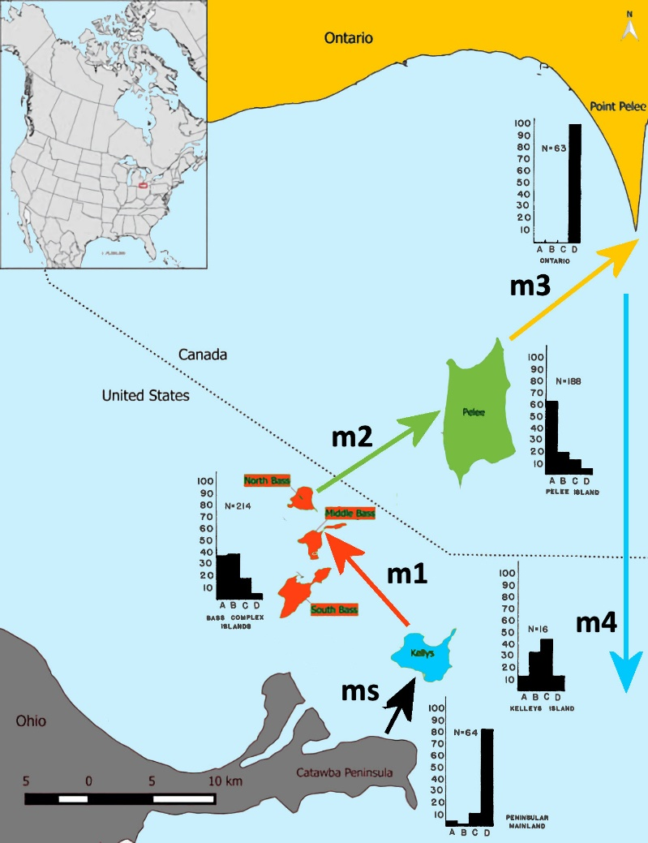
Figure 1 – Distribution of Nerodia sipedon insularum in Lake Erie. Minor islands not shown. Observed banding phenotype frequencies from Camin & Ehrlich (1958): Category “A” unbanded, Category “D” banded, Categories B & C.

Unidirectional migration rates m between the Ohio mainland and among islands are color coded as in Figure 2. The migration rate m_{X} is the rate from island ‘X’ to island ‘X+1’ with initial q_{x+1.} m₄ is the return rate from Point Pelee to Kelly’s Island. Initial frequencies for ‘banded’ allele f(B) on four islands are given in the instructions.
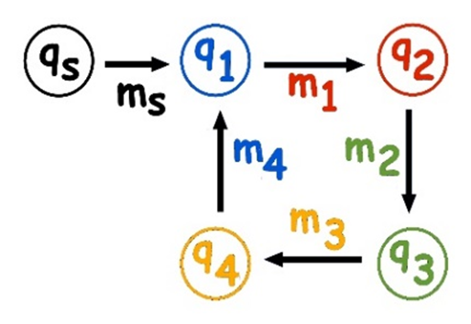

Instructions
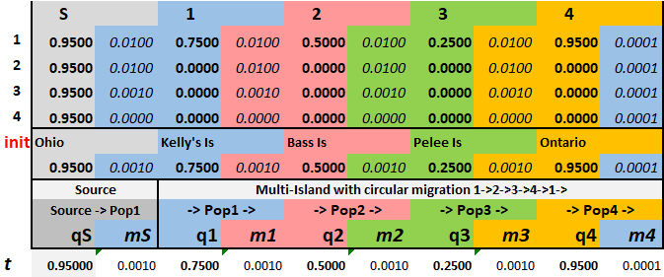
Set values of m according to an a priori migration model, and in combination with the table of ∆q under selection s, in the third section. Try (1) Relative distances declining among populations, by orders of magnitude [an inverse-log₁₀ relationship], (2) Constant, depending on choice of the selection scheme s, (3) a combination of (1) & (2) allowing the migration gradient values of m to vary by orders of magnitude.
To start the model running,
- Copy & Paste the values under S 1 2 3 4 into the line below the O K B P O line. This will reset the t line.
- Choose the column of ∆q for the chosen value of s. Copy & paste Values Only into Column AA: these are then automatically copied into Column L starting at Row 6 in the first section. [Be careful: overwriting values in the first five rows of Column L by simple pasting will destroy the calculations in the worksheet!].
- The values in the first section will then be re-calculated for the input values of s, q, and m. The graphical result of q for each population over time will change to something like this:
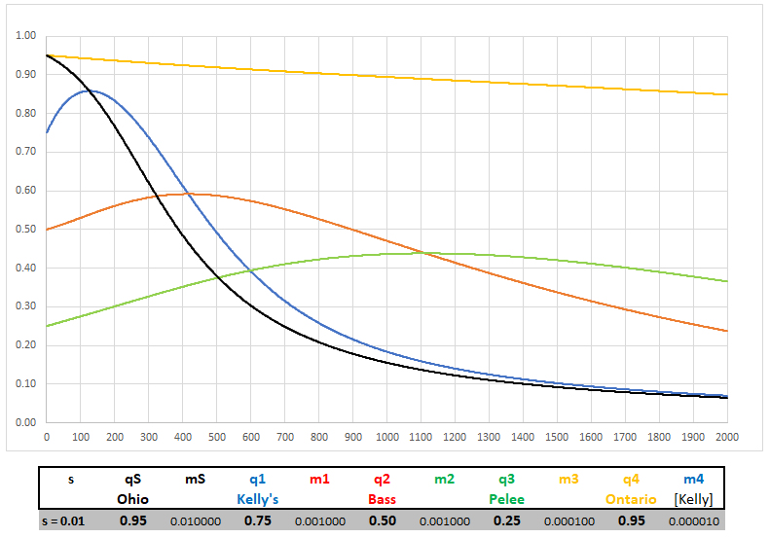
This scenario uses the initial data from Camin & Ehrlich, with s = 0.01 and migration rates between successive populations starting at s = m = 0.01 and decreasing approximately an order of magnitude with each doubling of distance [an inverse-log₁₀ realtionship]. Kelly’s Is, the closest to Ohio, quickly approximates the mainland. Both Bass and Pelee Is remain at relatively low f(B), with Pelee crossing Bass ~1,100 generations to a higher f(B) (Why?). The Ontario mainland retains a high f(B).
- Copy and paste the Excel block N36 – Z34 into a drawing program to retain the input parameters and the result. Repeat for all scenarios of interest. Use these figures to answer the questions in the Discussion.
Discussion
Consider the following points for interpretation and discussion.
- For any constant m among populations, how does varying s by plus-or-minus an order of magnitude modify the short-, middle, and long-term results?
- Same question, for a declining m proportional to distance among population?
- Does changing the model from a linear to a circular model change the result?

